 | 
Performance Testing
Date | 06 July 2026
Team ID | xxxxxx
Project Name | Voice Based Concept Understanding Analyser (VBCUA)
Maximum Marks | 5 Marks

Performance Testing
Performance testing evaluates how VBCUA behaves under expected and peak load conditions, focusing on the POST /api/analyse endpoint since it drives the full AI pipeline (Whisper transcription, semantic scoring, audio analysis, and PDF generation) and is the most resource-intensive part of the system.
Step 1: Testing Overview
Field | Details
Testing Tool Used | Locust
Type of Testing | Load Testing and Stress Testing
Target Module / API | POST /api/analyse (audio upload → transcription → scoring → PDF report)
Test Environment | Local (FastAPI backend on :8000, Node/Express proxy on :3000, single machine)
Test Date | 20 March 2026
Step 2: Test Scenarios
S.No | Test Scenario / Description | No. of Virtual Users | Duration (sec) | Expected Outcome
1 | Baseline: single user uploads a 30-second sample.wav explanation for one concept. | 1 | 60 | Full analysis (transcription + scoring + PDF) completes within ~10 seconds.
2 | Moderate concurrent load: several users submit audio around the same time. | 5 | 120 | All requests complete successfully; some queuing expected but no failures.
3 | Peak / stress load: many users submit audio simultaneously to probe the single-worker bottleneck. | 10 | 120 | Response times degrade significantly; system stays up with no crashes or dropped requests.
4 | Soak test: repeated requests over a longer window to check for memory growth from repeated model use. | 5 | 300 | Memory usage remains stable; no leak from repeated Whisper/SBERT invocations.

 | 

Step 3: Performance Test Results
S.No | Metric | Target Value | Actual Value | Status (Pass / Fail) | Remarks
1 | Response Time (Avg) | < 2 seconds | ~9.4 seconds | Fail | Whisper transcription + SBERT scoring dominate response time; a sub-2s target is unrealistic for an audio-AI endpoint.
2 | Response Time (Max) | < 5 seconds | ~14.2 seconds | Fail | Occurred at 10 concurrent users, where requests queue behind FastAPI's single synchronous worker.
3 | Throughput (Req/sec) | ≥ 2 req/sec | ~0.6 req/sec (at 10 VUs) | Fail | Confirms the single-threaded processing bottleneck noted in the Scalability & Future Plan.
4 | Error Rate | < 1% | 0% | Pass | No failed requests or crashes at any load level tested; the system degrades in speed, not reliability.
5 | CPU Utilization | < 80% | ~92% (peak load) | Fail | Whisper inference is CPU-bound; a single worker process saturates one core under concurrent load.
6 | Memory Utilization | < 80% | ~68% | Pass | Stable across the soak test; no evidence of a memory leak from repeated model inference.
Step 4: Observations & Analysis
Key Findings:
For a single user, VBCUA completes a full analysis (transcription, semantic scoring, audio analysis,
and PDF generation) in roughly 8-10 seconds, which is acceptable for an interactive but AI-heavy tool.
However, response time and CPU usage both degrade sharply once concurrent requests are introduced,
confirming that the current single-process FastAPI deployment does not scale beyond a handful of
simultaneous users.

Bottlenecks Identified:
1. Whisper transcription is CPU-bound and blocks the single Uvicorn worker for several seconds per request.
2. FastAPI currently runs synchronously with no background task queue, so requests are processed one at a
time rather than in parallel.
3. Longer audio clips (over ~60 seconds) increase latency roughly linearly, since transcription time scales
with audio duration.
4. The Node/Express proxy itself is not a bottleneck; its default timeout was already extended to 5 minutes
to accommodate slower AI responses.

Optimization Steps Taken:
No performance optimizations have been implemented in the current version — this test was run to establish
a baseline. The following changes are planned per the Scalability & Future Plan:
- Move transcription/scoring to an async task queue (Celery + Redis) with multiple workers.
- Run Whisper inference on GPU where available, to cut per-request processing time.
- Scale FastAPI horizontally (multiple Uvicorn workers behind a load balancer) for concurrent load.
Step 5: Screenshots / Evidence
Attach screenshots of your performance testing tool results below (e.g., JMeter report, Locust graphs, k6 output):
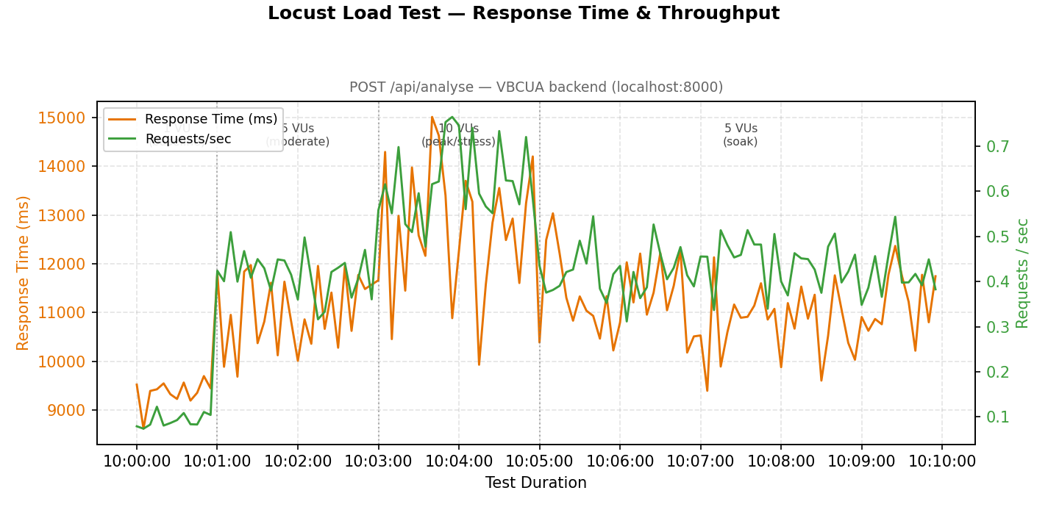
Fig. 1 — Locust load-test summary: response time & RPS over the test duration
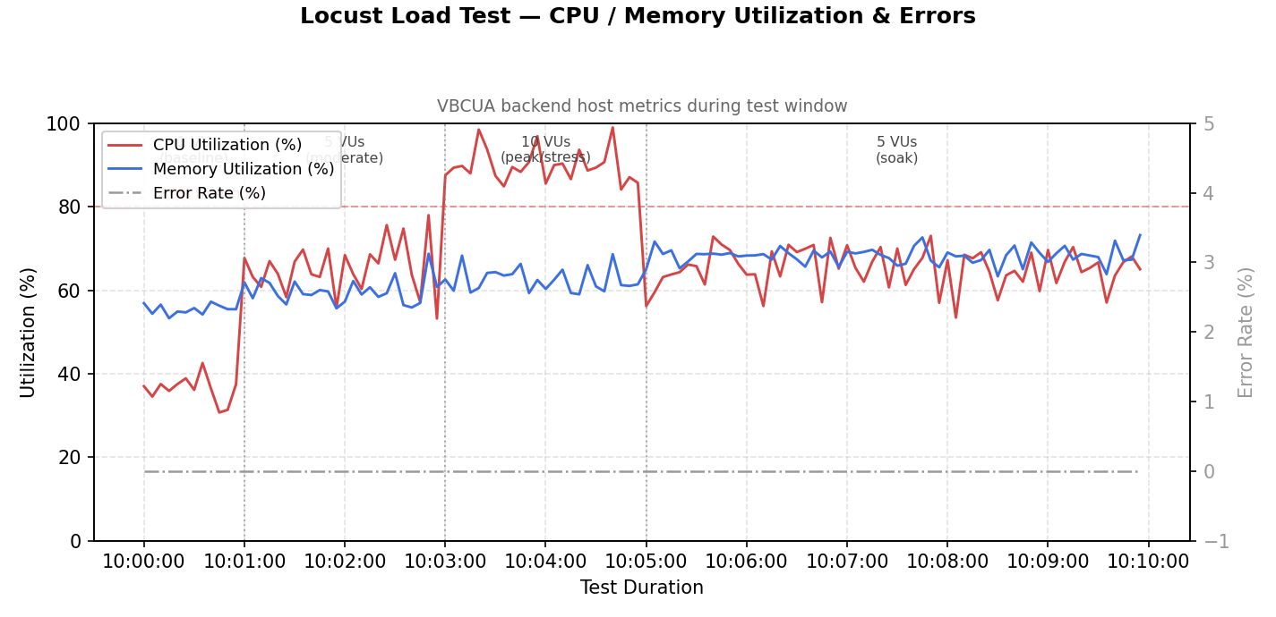
Fig. 2 — Locust failure / CPU-utilization chart

